Class test| FM-15|Coal and Petroleum
1. Cleanest fuel among the following is
a. Kerosene b. Petrol c. Cow dung cakes d. Hydrogen gas
2. Ammoniacal liquor is used for making
a. Candles b. Nitrogenous fertilizers c. Paints d. LPG
3. Full form of PCRA.
4. Observe and write their connection
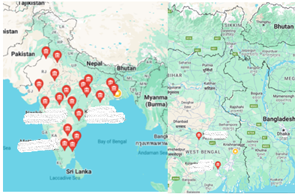
5. Observe and write their connection
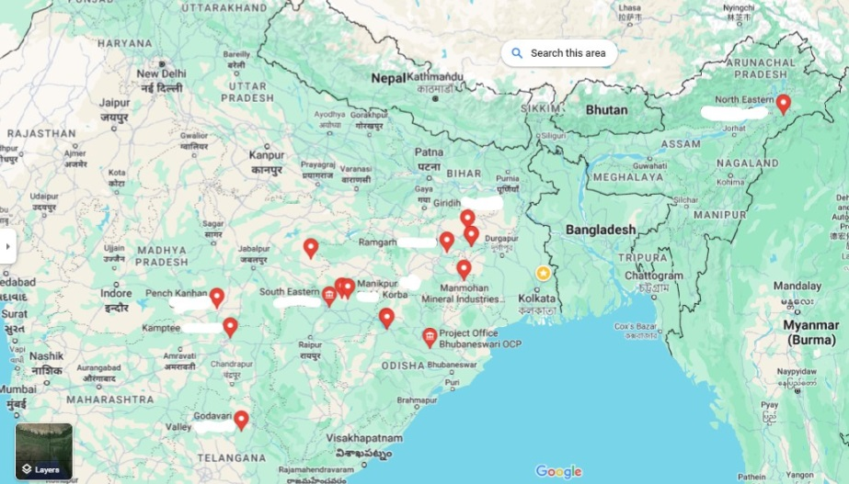
6. One of the largest coal field in India, mention the state of India
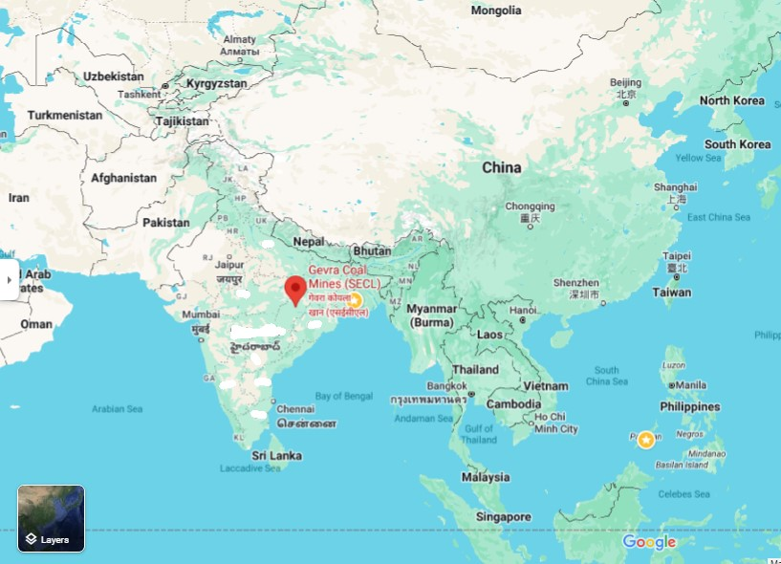
7. Draw a neat diagram of the set-up of apparatus for heating of coal in the school chemistry lab. Label six parts. (2+3=5)
8. Write two disadvantages of solar energy.
9. Full form of LPG, CNG
10. Write the concept of carbonisation.

